Jacky Zhang  
William Chen

CSI-300

Prof Frank Canovatchel

PROJECT 2 REPORT

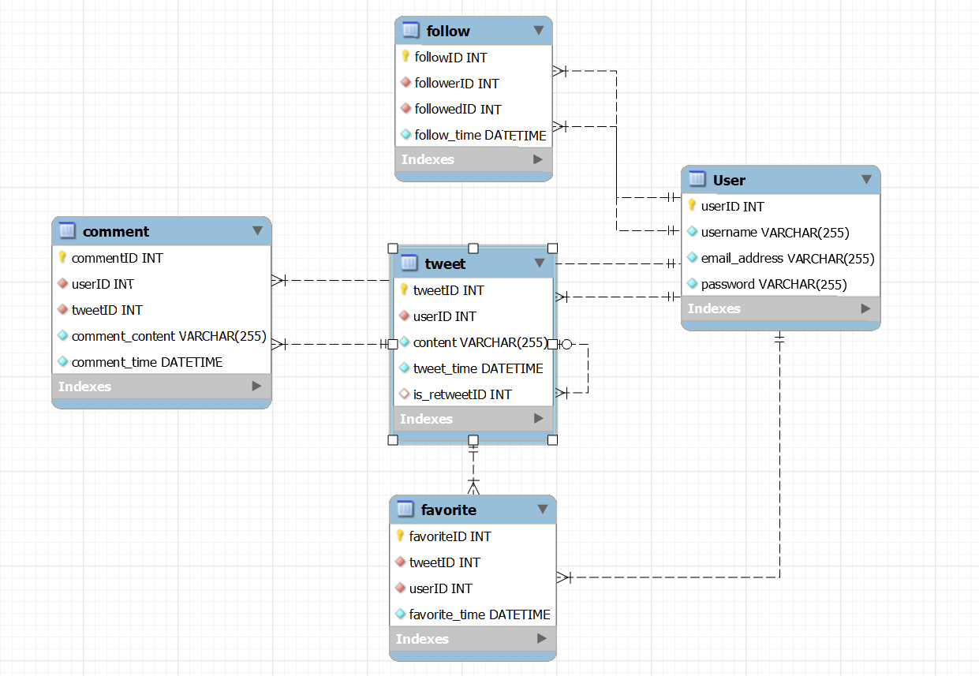

This report provides a breakdown of our Twitter clone. The Twitter clone covers essential functionalities such as posting tweets, following users, commenting on tweets, marking favorites, and retweeting. The primary focus is on the database schema, table relationships, and the implementation specifics we have created to support scalability and data integrity.

Each table serves as a function that is needed for the Twitter clone. The first table is the User table. This table serves as the base platform for the rest of the tables. The User table stores user information, including their username, email, and password. Each user is assigned a unique UserID to support scalability as more users sign up for Twitter and want to make an account. The next table is the Tweet table which is what makes the Twitter clone the Twitter clone. The Tweet table holds tweets posted by users. Each tweet is linked to a user via UserID and can optionally be a retweet of another tweet, denoted by IsRetweetID. The next table is the comment table. This is another example of scalability as another unique way to interact with a user's tweet. Since commenting has multiple attributes it will have its separate table. The Comment table holds comments made by users on tweets. Each comment is linked to both the User and the Tweet tables by userID and tweetID, to indicate who commented and on which tweet. The next table is the Follow table. The Follow table records the following relationships between users, with FollowerID and FollowedID pointing back to the UserID in the User table. The next table is the Favorites table. It tracks tweets that users have marked as favorites, linking users to tweets they favorite.

The Twitter clone is meant to be simple yet effective. Some relationships to create this Twitter clone are User to Tweet: One-to-Many. Each user can post multiple tweets, but each tweet is posted by only one user. Another one is Tweet to Comment: One-to-Many. Multiple comments can be made on a single tweet. Covering the basics by utilizing the right relationships to create a seamless Twitter clone.